Article Title (Capitalize Each Word - Times New Roman 20 pts)

Author1, Author2, Author2...dst (Times New Roman 14 pts)

1Institutional Name, City, Country (Times New Roman 10 pts)

2Institutional Name, City, Country (Times New Roman 10 pts)

**Abstract**: Please write the abstract in English, with a maximum of 250 words. The abstract contains the purpose and scope of the study, the method used, a summary of results, and a conclusion. These instructions give you guidelines for preparing papers for Jurnal Jaminan Kesehatan Nasional. Use this document as a template using Microsoft Word 7.0 or later. Otherwise, use this document as an instruction set. Define all symbols used in the abstract. Do not cite references in the abstract (Times New Roman 1.15 space - 11 pts).

**Keywords**: Put 3—5 of your keywords here; keywords separated by a semicolon

# Introduction (Heading 1 - Capitalize Each Word - Times New Roman 16 pts)

The introduction should contain (in sequence) a general background, a study of the state of the art as the basis for a scientific statement of novelty of the article, a statement of scientific innovation, and a research problem or hypothesis. The purpose of the article’s study should be written at the end of the preliminary section. In the format of a scientific article, there is no permission for a library review as in the research report. Still, it is realized in the form of a state-of-the-art study to demonstrate the scientific relevance of the article.

The paper size must match the A4 page size, i.e., 210 mm width (8.2’’) and 297 mm length (11,69’’). Margin limits are set as follows:

1. Upper = 25 mm
2. Lower = 20 mm
3. Left = 30 mm
4. Right = 20 mm

# Method (Heading 1 - Capitalize Each Word - Times New Roman 16 pts)

The methodology section contains the research plan, research subject, instruments, data collection procedures, and data analysis presented in the form of paragraphs.

Paragraphs must be in order. All paragraphs must be written using justified alignments, i.e., equally left and right.

The entire document must use Times New Roman fonts. Type 2 fonts should not be used. Other fonts can be used if necessary for specific purposes. Table 1 shows the font size feature.

Heading should not exceed three levels. All headings should be in Times New Roman font. Here is how the heading is written:

1. Heading Level 1: Heading level 1 should be all capital letters, thick printed, and left flat—for example, METHOD
2. Heading Level 2: Level 2 should start with the capital letters, left and right plate. For instance, Heading 2.
3. Heading Level-3: Heading: Level 3 heading must begin with the main letters, the thickprint, the sloping (italic), and the left plane.

The chart and table should be located in the middle (centered). Any table or picture should be positioned at the top or bottom of the page. Loading tables or images must be mentioned in the sentence. Text in a table using single-spaced or space 1

Color graphics are permitted. As shown in Figure 1, contrasted compact coloring should be used for a computer screen display and a black-and-white print.

Figure 2. shows an example of an image with a low resolution that is less appropriate, while Figure 3. shows an example of a picture with an adequate resolution. Check that the image resolution is sufficient to reveal essential details on the image.

Table 1. Font size for paper

|  |  |  |  |
| --- | --- | --- | --- |
| Font Size | **Display (in Times New Roman)** | | |
| **Normal (Regular)** | **Thick (Bold)** | **Oriented (Italic)** |
| 10 | Author email address,  cell in a table, affiliation |  |  |
| 11 | Abstract, keyword | Table Description, Image Description | item reference (partial) |
| 12 | paragraph | Heading level 2 | Heading level 3 |
| 14 | Author name |  |  |
| 16 |  | Heading level 1 (capitalize each word) |  |
| 20 |  | Title |  |

# Results (Heading 1 - Capitalize Each Word - Times New Roman 16 pts)

The result section contains research findings derived from research data and related to the hypothesis.

Please check all images in your journal, both on screen and in print. When checking the printed version of the image, make sure that (1) the color has sufficient contrast, (2) the image is sufficiently clear, and (3) all labels on the image are readable.

The image is numbered using numbers. The image description must be in a regular font size (Times New Roman 11 pts). The picture description in one line is placed in the center, while the multi-line description should be arranged to the left. The image's description with the image number should be placed after the related image.

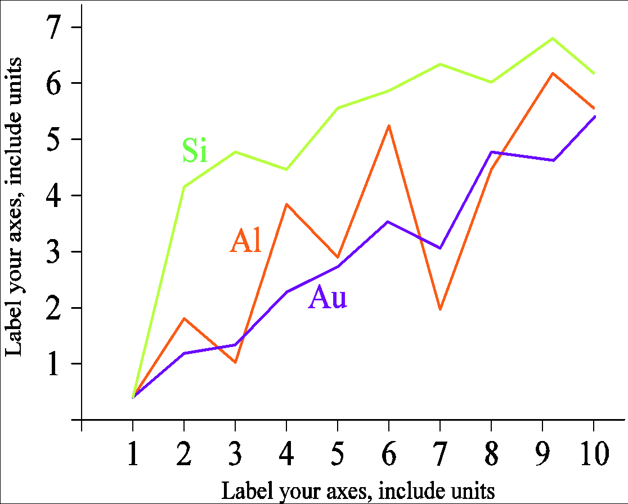

Figure 1. Example Line Graphics Using Contrasting Colors

## Heading 2

The table is numbered using the table description on the left and in standard font size. Times New Roman 10 pts.

### Heading 3

Page number, header, and footer are not used. All hypertext links and bookmark sections will be deleted. If the paper needs to refer to an email address or URL in the article, the address or full URL should be typed in a regular font.

The equation is sequentially followed by the number decomposition in the curtain mark with the right flat margin, as in (1). Use the equation editor to create equations. Give tab spaces and write the equation number in the curtain. Use a bending line mark ( / ), a rank function, or an appropriate rank to make your equation closer. Use curtains to avoid variations when giving fractional numbers. Explain the equation when in part of a sentence as follows:

 (1)

Ensure that the symbols in the equation have been defined before the equations or immediately followed after they appear. Symbols typed with bending letters (T does not refer to temperature, but T is a unit of Tesla). Refer to “(1)”, not “Pers. (1)” or “equality (1)”, except at the beginning of the sentence: “Equity (1) is...”.

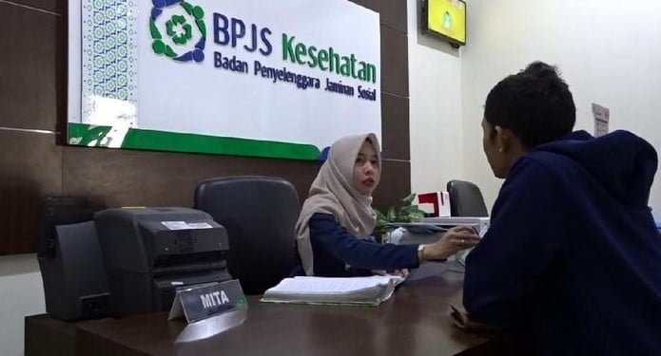

Figure 2. Example Picture with Low-Resolution

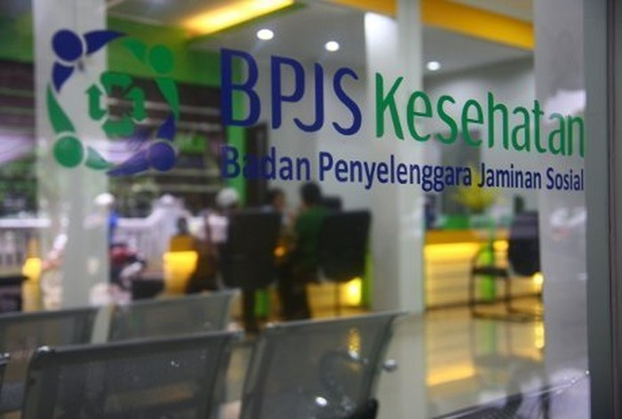

Figure 3. Example image with sufficient resolution

# Discussion (Heading 1 - Capitalize Each Word - Times New Roman 16 pts)

The research discussion section contains discussions of research results and comparisons with theory and/or similar research.

## Heading 2

The table is numbered using numbers—table description on the left-and in standard font size Time New Romans 9 pts.

### Heading 3

Page number, header, and footer are not used. All hypertext links and bookmark sections will be deleted. If the paper needs to refer to an email address or URL in the article, the address or full URL should be typed in a regular font.

# Conclusion (Heading 1 - Capitalize Each Word - Times New Roman 16 pts)

This section summarizes the answers to the hypotheses, purposes, and findings of the research and suggestions related to further research ideas. Conclusions are presented in paragraph form.

# Acknowledgement (If Any) (Heading 1 - Capitalize Each Word - Times New Roman 16 pts)

The title for the thank-you speech and the reference are not numbered.

# References (Heading 1 - Capitalize Each Word - Times New Roman 16 pts)

All references in the article text must be listed in the Library List section. Writing a bibliography and quotations in the APA 7th edition style is recommended using the Mendeley application. Each article must have at least 15 reference lists (Times New Roman 11 pts). The title on the reference section should not be numbered. reference must be posted in the left-right alignment.

Falvo, D. R. (2011). *Effective patient education: A guide to increased adherence*. Sudbury, Jones, and Bartlett. 🡪 **Book, Report**

Hanggara, G. S., Andrianie, S., & Ariyanto, R. D. (2018). Pengembangan Aplikasi Assessment Menggunakan Media Short Message Service*. Jurnal Kajian Bimbingan dan Konseling,* *3*(4), 146–153. <https://doi.org/10.17977/um001v3i42018p146> **🡪 *Journal article***

Norris, F. (2010, Agustus 21). For a change, U.S. debt is staying in the U.S. *The New York Times*, p.B3. 🡪 **Newspaper**

Park, M. (2010, September 10). *Clues are found in mysterious childhood aging diseases*. CNN. http://www.cnn.com/2010/EALTH/09/10/ progeria.children.aging/ 🡪 **Website article**

Rich, N. (2010, September 2). The most dangerous man in cyberspace. *Rolling Stone*, (1112), 71-73 🡪 **magazine**

Shelly, D. R. (2010). Periodic, chaotic, and doubled earthquake recurrence intervals on the deep San Andreas fault. *Science, 328*(5984), 1385-1388. 🡪 ***Journal article***

Sparrow, D.G. (2010). *Motivasi Bekerja dan Berkarya*. Citra Cemerlang. 🡪 **Book**

Widarjono, A. (2017). *Analisis multivariat terapan dengan program, SPSS AMOS & SMARTPLS*. UPP STIM YKPN. 🡪 **Book**

Winkel, W. S., & Hastuti, M. S. (2005). *Bimbingan dan Konseling di Institusi Pendidikan*. Media Abadi. 🡪 **Book**